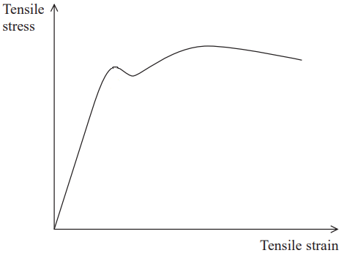**Q1**) a) using the graph on the right:

Draw and label point **A** for limit of proportionality  
 Draw and label point **B** for Elastic limit  
 Draw and label point **C** for Yield point  
 Draw and label point **D** for Ultimate tensile stress  
 Draw and label point **E** for Breaking point

b) On the same graph draw a second curve representing a stiffer material than the one in the graph

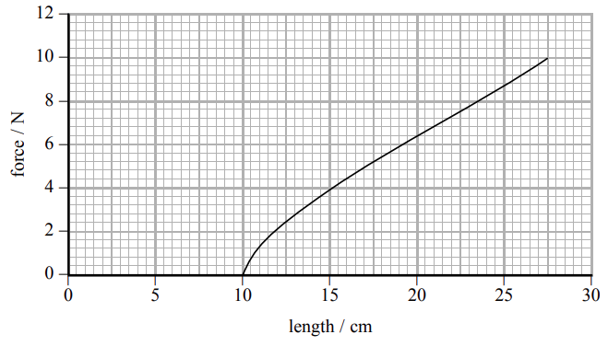

**Q2**) The graph on the right represents the properties of a rubber band,

a) calculate the elasticity constant for the rubber band

b) calculate the work done on the rubber band

c) assuming the rubber band has a mass of 8g, what would be its maximum velocity *hint: $KE=1/2mv²$*

**Q3**) Encircle the correct answer  
**1.** The stress that acts on a vertical wire with a load attached on it doesn’t depend on:  
 **a.** Length of the wire **b.** Diameter of the wire **c.** Mass of the load **d.** Gravitational acceleration  
**2**. The limit of proportionality in Hooke's Law is the point where:  
 **a.** The material permanently deforms **b.** The force is no longer proportional to extension  
 **c.** The spring constant changes **d.** The material becomes inelastic

**3.** A material with a high Young's Modulus is likely to be:  
 **a.** Very elastic **b.** Very inelastic **c.** Very ductile **d.** Very brittle

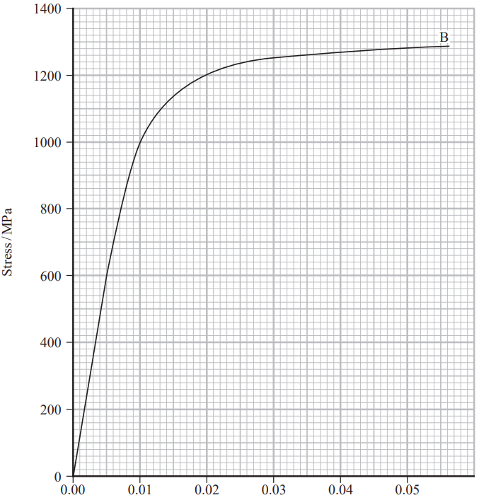**Q4**) a sample of titanium alloy was subjected to a tensile force. The sample had an original length of 40 cm, and a diameter of 5.05 mm,   
 a) determine the material’s Young’s modulus  
 b) Determine the force required to break   
 the sample.

Extension (m)